**Use Case**:

User can manage their spending by entering the date, amount of money they deposit or spend and can review the transactions in the history section and have a clear view of their current balance.

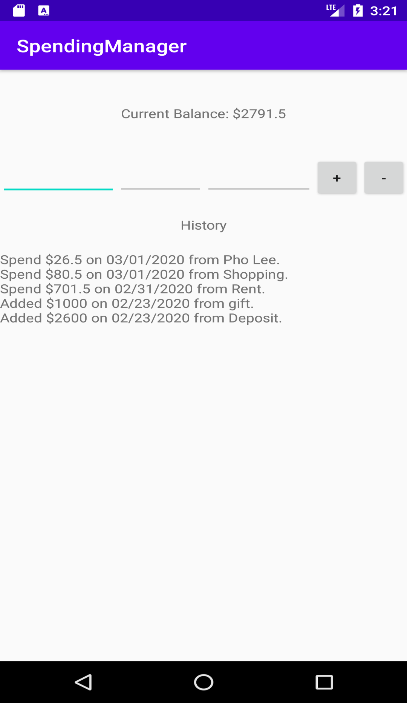

First, user enter the date of the transaction on the first underline:

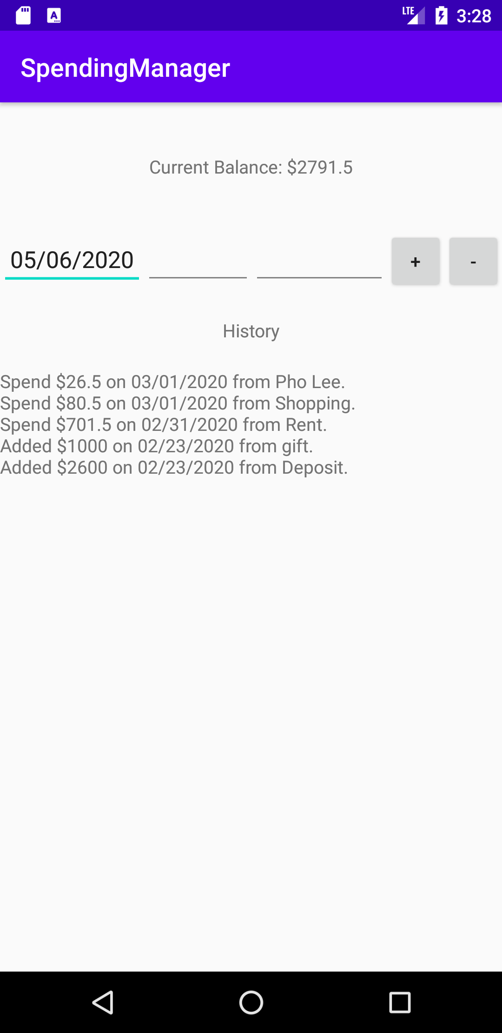

Then user can enter the money amount on the second underline:

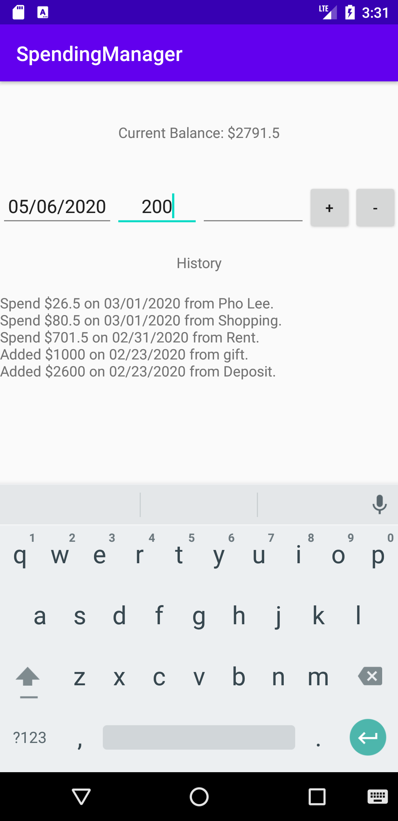

After that, user can demo what the money was on the third underline:

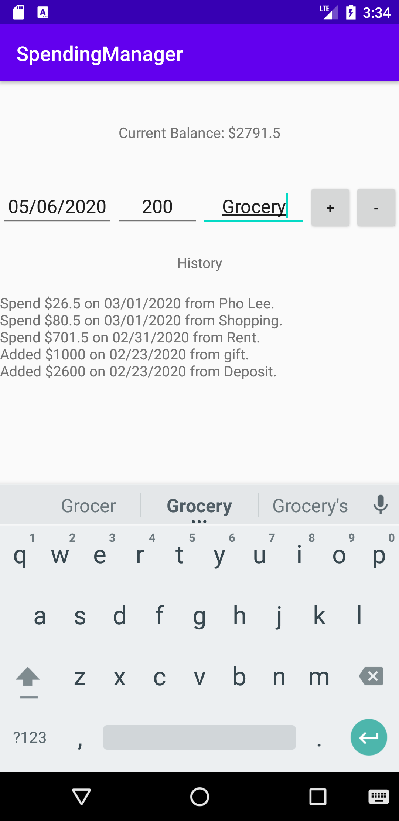

At the end, user decide if this transaction is a deposit or spending by clicking on the “+/-” button separately:

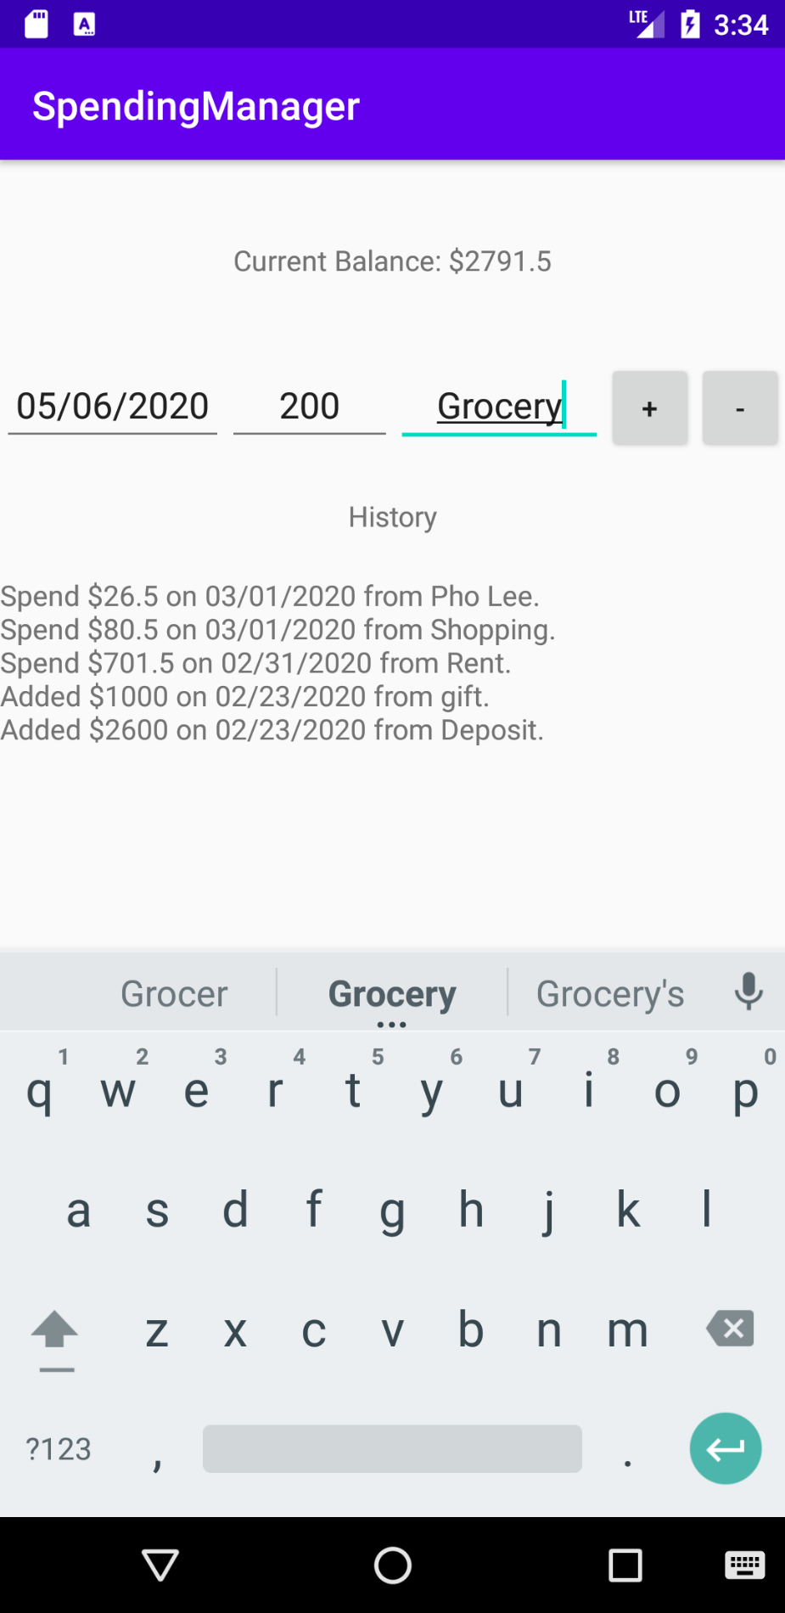

The transaction is recorded in the history:

